Course Project Use Case Analysis

1. As a user, I want to check out an order in store for a customer.

|  |  |
| --- | --- |
| **User** | **System** |
| 1. Logs into the system. | 1. Presents options on a home screen to either checkout, add new product, or edit current products. |
| 1. Chooses the option to check out. | 1. Presents a blank screen ready for the user to input product information. |
| 1. Enters the barcode number of the item. | 1. The product shows up on the screen, and the price of the item is added to the total. |
| 1. Step 5 is repeated until all of the items have been scanned. | 1. Step 6 is repeated until all of the items have been scanned. |
| 1. Chooses “pay now.” | 1. The tax is added to the item total, and the inventory is updated. |
| 1. The payment is made. | 1. Displays “Thank you for shopping with us!”, prints a receipt, and returns to the home screen. |

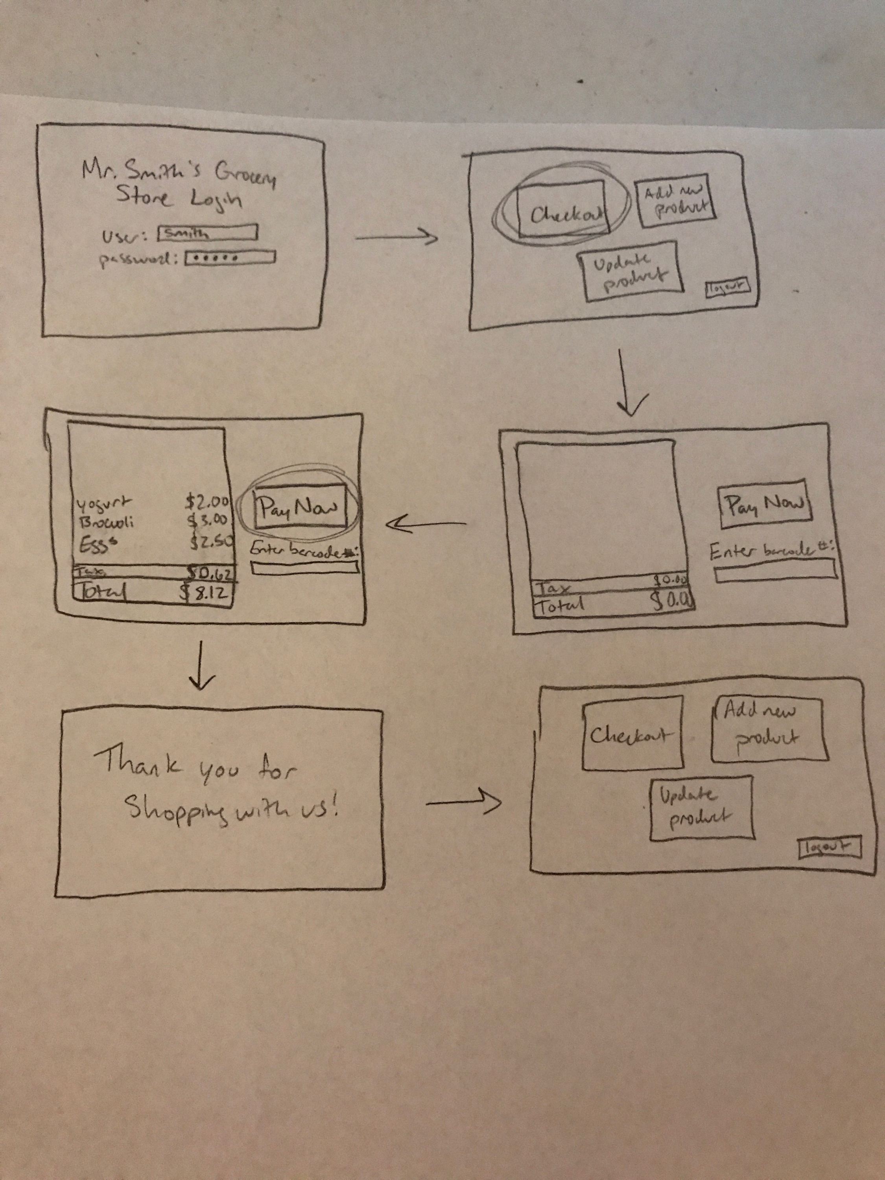

1. As a user, I want to add a new product into the system.

|  |  |
| --- | --- |
| **User** | **System** |
| 1. Logs into the system. | 1. Presents options on a home screen to either checkout, add new product, or edit current products. |
| 1. Chooses the option to add a new product. | 1. Presents a screen with fields for name, barcode number, number of units, price, provider name, provider phone number. |
| 1. Fills in information for the product and chooses “add.” | 1. Displays “Item has been added!” and returns to the home screen. |

